**CMPSC 412 – Lab-8** (25 points)

**Binary Search Tree**

**Due date: 3/22/2022**

**Lab Exercises:**

In continuation of Lab exercise 6.2.

**Exercise-1:**

In continuation of Lab exercise 6.2., Develop a Binary Search Tree (BST) which can perform the following functions:

* Insert a new student with unique PSU ID to the database using BST
* Find a student using PSU ID
* Print each student with all details

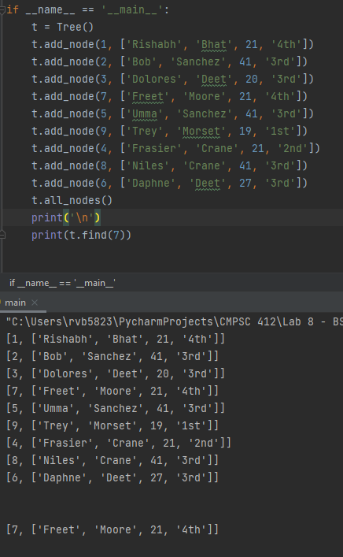w

**Exercise-2:**

* Write a function which takes a list of elements and builds a Binary search tree?
* Given a binary tree, check whether the given binary tree is a valid binary search tree (BST) or not.

Note: create a tree with minimum 10 values and demonstrate all the functions. Attach the screenshots of the results.

